August 2024 Z-Wave RF Range Testing

# Executive Summary

Coming once the testing is complete

# Goals

* ZRAD to ZRAD ZWLR RF range testing in various environments generating a Heat Map using Geographic Location Command Class and a GPS receiver
* ZRAD End Device Mounted on a Motorcycle to move around quickly
  + Some data may be captured using an eBike or walking especially in urban environments
* ZRAD Controller running Z-Wave JS to pull GPS locations and store in a .CSV file
* What effect does the ground plane size have on RF range?
  + Can a thunderboard have significantly more range if placed on a metal plate?
    - How big of a plate? What shape?
    - Try this around the Shaw fields as an easy test location
  + Same applies to ZRAD
  + Can a smaller ZRAD sitting on a 6.5” radius plate achieve the same RF performance (or better) as ZRAD (thus a smaller and cheaper PCB)
  + Does a larger plate improve it even more?
  + Are 4 rods at 45 degree angle even better?
* What is the best RF performance at a reasonable cost?
  + The ZRAD is too big to be practical for a commercial product
  + Is it better to ship a metal plate or 4 rods? Can the customer easily add a plate if they need a little more range?
* Environments:
  + Wooded
    - [Bound](https://www.google.com/maps/place/BoundTree%2FLine+Hill+Parking/@43.2080352,-71.7716687,280) Tree ATV Henniker NH
    - Rockingham [trail](https://www.nhstateparks.org/find-parks-trails/recreational-rail-trails/rockingham-recreational-rail-trail,-fremont-branch) Freemont to Sandown
    - [Hopkington-Everet OHRV](https://www.google.com/maps/place/Hopkinton-Everett+OHRV+Trails+Area/@43.1239432,-71.6538497,1887) trails
  + Open agricultural field
    - Wagon Hill Durham NH (not quite big enough?)
  + Green houses?
  + Residential
    - Newton MA
    - Dover NH
  + Urban
    - Boston Silabs Office
      * Do the windows have metal tinting with poor RF?
      * Can we get on the roof? Probably not
      * Use the top floor of the NECCO parking deck?
      * Street parking Dorchester Ave above the bass river outside the Gillette visitor parking lot: [42.345363, -71.057275](https://www.google.com/maps/place/42%C2%B020'43.3%22N+71%C2%B003'26.2%22W/@42.3451982,-71.0575464,84m/data=!3m1!1e3!4m4!3m3!8m2!3d42.345363!4d-71.057275!5m1!1e3?entry=ttu)
        + Just over 1km down the bass river and several parking lots
    - Dover NH
      * Controller on top of the [Garrison Hill tower](https://www.google.com/maps/place/Garrison+Hill+Tower,+Abbey+Sawyer+Memorial+Hwy,+Dover,+NH+03820/@43.2094265,-70.8704013,333) which has line-of-sight to much of Dover below for several miles and plenty of urban streets
        + Too many trees – do not use
        + Can drive & park at the base of the tower
        + Trial on 8/10 did not go well. Too many trees surrounding the tower results in few if any pings even on the road just below the tower. Only time it connects is line-of-sight which is rare at ground level.
      * [Shaw Fields](https://www.google.com/maps/@43.1664761,-70.8689548,396m/data=!3m1!1e3!5m1!1e3?entry=ttu#:~:text=43.165965%2C%20%2D70.869717) is an open area surrounded by neighborhoods somewhat hilly but did yield good results
    - Strafford NH
      * The [Stratham Hill Tower](https://www.google.com/maps/place/Stratham+Hill+Tower/@43.0312354,-70.8911063,3178) is an alternative but doesn’t have as many streets nearby
      * Requires a hike up the hill to get to the tower
    - Salisbury Beach – 5 miles not quite LoS
      * [42.823773, -70.813928](https://www.google.com/maps/place/42%C2%B049'25.3%22N+70%C2%B048'50.0%22W/@42.8236998,-70.8187629,797)
      * Parking lot close to the beach then follow Atlantic Ave for a mostly line-of-sight range. Not perfect but could give as much as 5 mile range.
      * Parking lot is behind dunes with no real LoS down the beach or street
    - **North Beach** – 1.6mi LoS along Ocean Blvd
      * [42.920850, -70.798394](https://www.google.com/maps/place/42%C2%B055'15.1%22N+70%C2%B047'54.2%22W/@42.920851,-70.7990377,199)
      * Free? Parking at south end of the beach then a clear LoS along the beach with a sidewalk with a 4-5 foot concrete wall so both ends have to be elevated to ~6 feet.
      * Possibly extend to 2.7mi to North Hampton State beach with a gap due to the peninsula at Ancient Hgwy
    - Philbricks Beach/ Rye beach – 1.4mi but no parking
    - York Beach – 1.6mi LoS then Nubble Lighthouse neighborhood
      * [43.147698, -70.626328](https://www.google.com/maps/place/43%C2%B008'51.7%22N+70%C2%B037'34.8%22W/@43.147699,-70.6269717,198)
    - Plum Island beach – no parking near the beach, too sandy
  + Water – need a boat – lakes or the ocean depending on the weather
* At some point:
* Use ZRAD to capture GPS, but also capture stats of other devices
  + Use Indicator Get? ZWInfo Get? Needs to be a secure GET to know frame made both directions clean
  + ZW mesh with ZRAD
  + Commercial products
    - Ring
    - Zooz light switch? Blink xmas lights all over the bike and night Electric Cowboy style!
      * Need a large battery and inverter – Jackery?
    - 3Labs flow meter
* Compare with Wifi, Zigbee, Matter, Lora, others?
  + 2.4 protocols in urban environments will probably suck due to all the noise
* Compare with YAGI antenna – point-to-point
* Example use-cases
  + Track skydiving jump (Homeseer)
  + Track model rocket launch
  + Track glacier movement for months at a time (need low-power)

# Journal

## 2024-08-16 – BoundTree ATV trails in NH

Completed shooting the video out at a dairy farm in Henniker NH and at the BoundTree Trails in Henniker NH: [43.207900, -71.771031](https://www.google.com/maps/@43.2076885,-71.7710248,140m/data=!3m1!1e3!5m1!1e3?entry=ttu)

No data was captured at the dairy farm as we couldn’t travel around the fields. The corn was 7’ tall so getting thru it would limit the range. Would need to mount the controller up high on a barn roof for the range to be good.

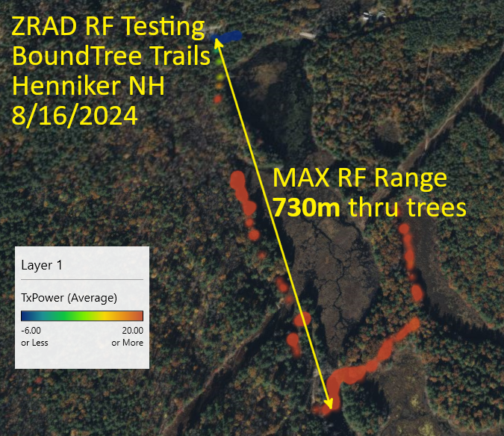Data has captured at Bound Tree but again the focus was on the video with limited real data captured. The .csv file is 20280817BoundTree.csv. The problem with this location is that the forest is dense so range is limited. RF Range is 730m thru a lot of trees but at full power and was marginal much of the time. Wanted to have Mark spiral out across many of the trails but ran out of time.

## 2024-08-16 – Downtown Boston

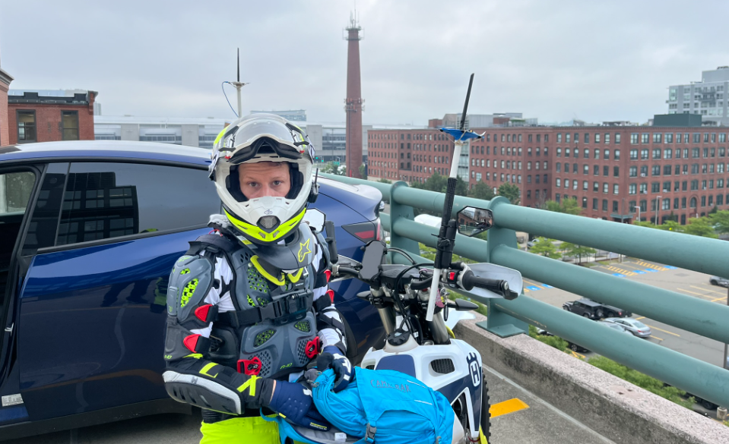While shooting the Works With video, the hope was to capture data in the city environment near the Silabs office. The Necco street garage has a decent view down the harbor but there are many concrete and steel tall buildings in the area which will limit RF range.

We were there early in the morning shooting the video on the empty top floor. However, security came up and said we cannot shoot video and made us leave before we could capture any significant amount of data. The file is 20240815Boston.csv.

The date/time isn’t incrementing in the .csv file. Moved the capture of the Date to within the While loop.

## 2024-08-12 – Shaw Fields Dover NH

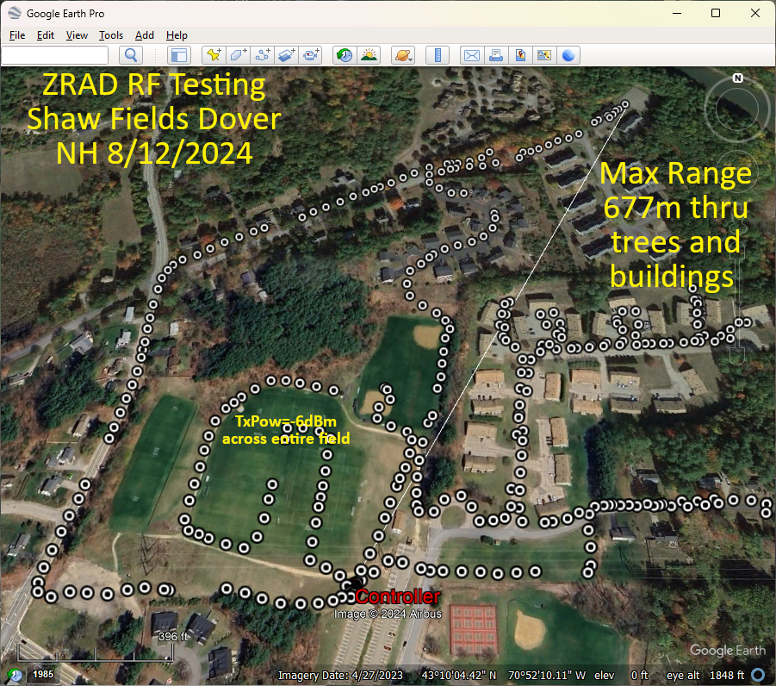The Shaw fields in Dover are open fields surrounded with neighborhood streets. The area is hilly but the fields are flat with the parking lot on a hill overlooking them. There is only about 300m of direct line of sight. Time didn’t allow capturing the entire area and I was walking but an eBike with a faster sample rate would be a better idea to get more data faster.

The fields yielded -6dBm TxPower levels at over 150m. The longest range is 677m but that includes numerous trees and wood frame condos in between. TxPower is +20 at that extreme.

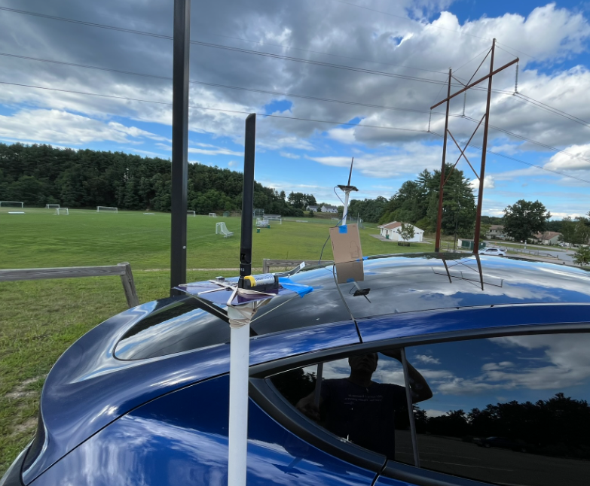The controller is mounted about 24” above a Tesla on a PVC pipe. Is the roof of the car providing additional ground plane effect to increase range? Will have to experiment with the controller standalone well away from any metal. If that is much shorter, then we’ll have to try with a cookie sheet or circular cardboard wrapped in aluminum foil! Maybe 4 or 8 rods at a 45 degree angle?

Google Earth Pro (download the desktop version) creates the image above via:

1. Edit the .csv to have only the data to be plotted
2. Open GEPro
3. File->Open
4. Select Generic Text (*.csv)
5. Pop-up will open to select the columns
6. Latitude and Longitude are usually detected automatically from the 1st row of the .csv
   1. If not, select them
7. Change the format from STRING to FLOATING POINT (this is the key)
8. Click on Finish
9. View-> check Sidebar
10. Scroll down to the imported file, click the check on and the points will be displayed
11. Use Add Path to add a path – the length is shown in the Length tab (change to meters)
12. In the sidebar, select the Controller data point, change its name and color
13. Screen shot then add more text to the image using Gimp

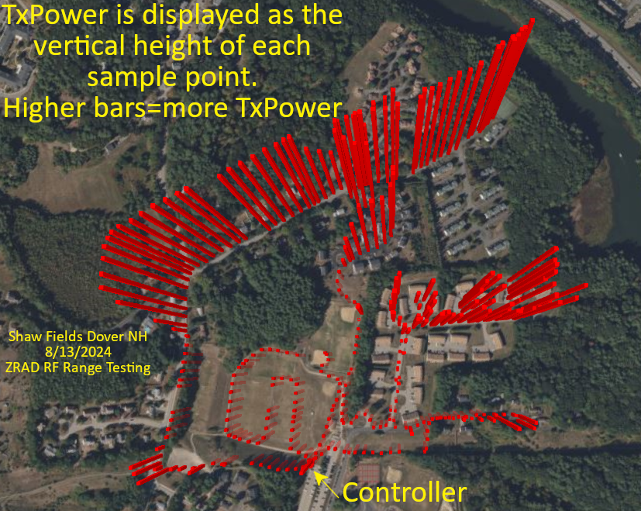This image is created using Excel 3D maps feature

1. Open the .csv in Excel
2. Save the file as .xlsx
3. Click on 3D Maps (if not in the toolbar, search for it)
4. The 3D maps app should open and automatically find the Latitude and Longitude
5. Zoom in on the location – the points are all mashed together as the dots are far too large
6. Layer Options
   1. Reduce size to 0
7. Click on Height and add TxPower – reduce the height to zero percent
8. Change the color as desired
9. Themes -> select one with a satellite view
10. Screenshot and add more text using Gimp
11. 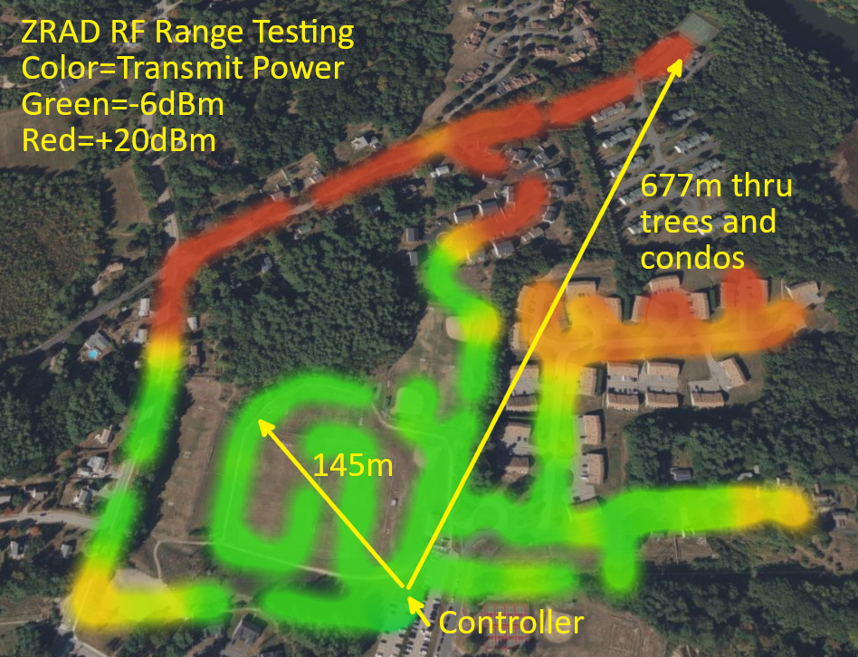To create a heatmap, click on the heatmap icon at the top of the Layer Pane
12. Change Visual Aggregation to Average
13. Adjust the radius of Influence and the color scale to the desired levels
14. Try other options
15. Screenshot and add text/arrows in Gimp

Raw data is in the file 202408ShawFields.csv checked into the ZRAD repo in the Test folder.

## 2024-08-10 – Dover Garrison Hill Tower

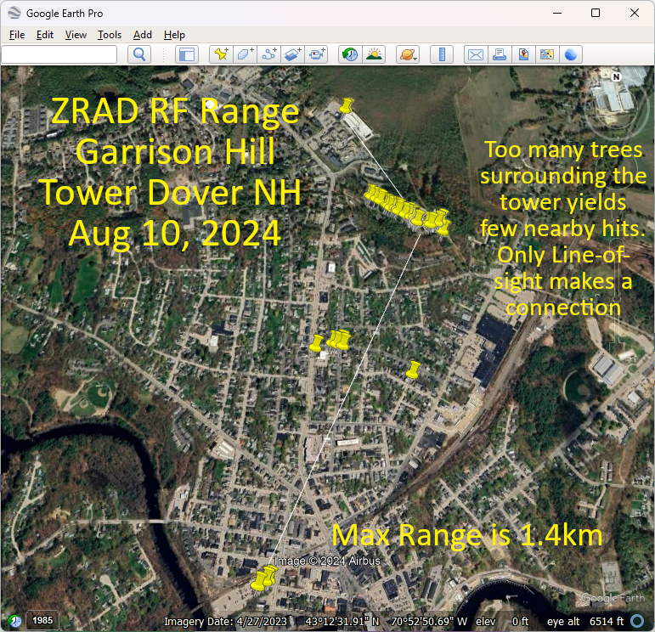Trial run at the Garrison Hill tower which has a commanding view of the city of Dover NH. The problem is the tower is surrounded with a thick forest which from the top of the tower you can just see over the tops of the trees. This means there are no connections made to the streets immediately below the tower thru all the trees. The few line-of-sight locations in the city will connect at over 1.4km but there are few of these at ground level. Lots of 3 story buildings and more trees block the LoS.

Download Google Earth Pro which can import the .csv file and display it on a map and take measurements. Note that the online version of Google Earth does NOT have the feature to import a .csv file. This does not appear to import the altitude, just 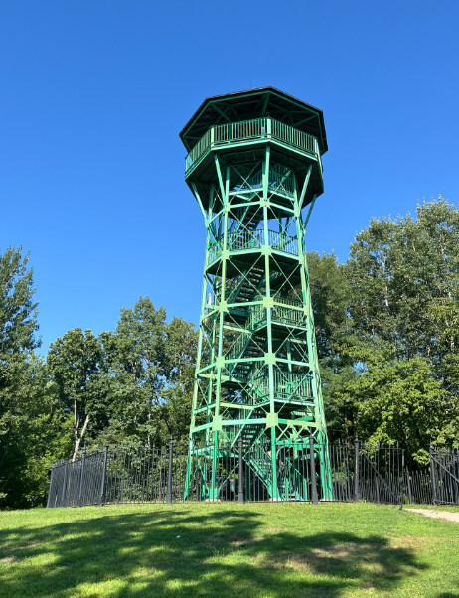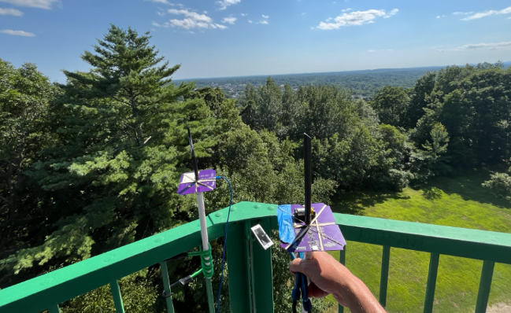Lat/Lon. Tried a few CSV to KML conversion utilities but GE still doesn’t seem to how the altitude.

Still looking for a mapping solution that will produce a 3D model for skydiving or rocketry that shows the altitude.

Raw data:

Time, Latitude, Longitude, Altitude, TxPower, RSSI, Sat Aug 10 2024 15:19:13 GMT-0400 (Eastern Daylight Time)

03:19:13 PM, 43.20914840698242, -70.8693618774414, 182.85, 0, 0

03:19:13 PM, 43.20912551879883, -70.86934661865234, 182.85, 0, 0

03:19:13 PM, 43.2091064453125, -70.86935424804688, 182.85, 0, 0

03:19:13 PM, 43.209556579589844, -70.8694076538086, 110.76, 0, 0

03:19:13 PM, 43.20950698852539, -70.86963653564453, 112.66, 0, 0

03:19:13 PM, 43.20948028564453, -70.86962127685547, 112.71, 0, 0

03:19:13 PM, 43.20952224731445, -70.86958312988281, 112.74, 0, 0

03:19:13 PM, 43.209510803222656, -70.86959075927734, 112.79, 0, 0

03:19:13 PM, 43.209510803222656, -70.86959075927734, 112.79, 0, 0

03:19:13 PM, 43.20949172973633, -70.86959075927734, 112.79, 0, 0

03:19:13 PM, 43.20949172973633, -70.86958312988281, 112.79, 0, 0

03:19:13 PM, 43.20948028564453, -70.86958312988281, 112.92, 0, 0

03:19:13 PM, 43.20948028564453, -70.86958312988281, 113.18, 0, 0

03:19:13 PM, 43.20948028564453, -70.86957550048828, 113.33, 0, 0

03:19:13 PM, 43.20948028564453, -70.86957550048828, 113.33, 0, 0

03:19:13 PM, 43.2094841003418, -70.86957550048828, 113.57, 0, 0

03:19:13 PM, 43.20949935913086, -70.86959075927734, 114.15, 0, 0

03:19:13 PM, 43.209503173828125, -70.86958312988281, 114.19, 0, 0

03:19:13 PM, 43.209495544433594, -70.86959075927734, 114.23, 0, 0

03:19:13 PM, 43.20949935913086, -70.86959075927734, 114.26, 0, 0

03:19:13 PM, 43.20949935913086, -70.86959075927734, 114.27, 0, 0

03:19:13 PM, 43.209495544433594, -70.86959838867188, 114.39, 0, 0

03:19:13 PM, 43.20949935913086, -70.86959838867188, 114.4, 0, 0

03:19:13 PM, 43.209495544433594, -70.86959838867188, 114.44, 0, 0

03:19:13 PM, 43.20949935913086, -70.86959075927734, 114.23, 0, 0

03:19:13 PM, 43.209503173828125, -70.8696060180664, 114.28, 0, 0

03:19:13 PM, 43.20951843261719, -70.86962127685547, 114.25, 0, 0

03:19:13 PM, 43.20949172973633, -70.86962890625, 114.39, 0, 0

03:19:13 PM, 43.20949172973633, -70.86962890625, 114.46, 0, 0

03:19:13 PM, 43.20948791503906, -70.86962890625, 114.72, 0, 0

03:19:13 PM, 43.20948791503906, -70.86962890625, 114.76, 0, 0

03:19:13 PM, 43.20949172973633, -70.86962890625, 114.76, 0, 0

03:19:13 PM, 43.209495544433594, -70.86962890625, 114.22, 0, 0

03:19:13 PM, 43.209495544433594, -70.86962127685547, 114.05, 0, 0

03:19:13 PM, 43.209495544433594, -70.86961364746094, 114.02, 0, 0

03:19:13 PM, 43.209495544433594, -70.8696060180664, 114.01, 0, 0

03:19:13 PM, 43.209495544433594, -70.8696060180664, 114.28, 0, 0

03:19:13 PM, 43.209495544433594, -70.8696060180664, 114.37, 0, 0

03:19:13 PM, 43.20949935913086, -70.86961364746094, 114.45, 0, 0

03:19:13 PM, 43.20950698852539, -70.86961364746094, 114.48, 0, 0

03:19:13 PM, 43.209495544433594, -70.86962890625, 113.76, 0, 0

03:19:13 PM, 43.209495544433594, -70.86963653564453, 113.7, 0, 0

03:19:13 PM, 43.20950698852539, -70.86963653564453, 113.49, 0, 0

03:19:13 PM, 43.209495544433594, -70.86964416503906, 112.86, 0, 0

03:19:13 PM, 43.209449768066406, -70.86972045898438, 113.86, 0, 0

03:19:13 PM, 43.20943069458008, -70.86981201171875, 116.74, 0, 0

03:19:13 PM, 43.20942306518555, -70.86993408203125, 118.76, 0, 0

03:19:13 PM, 43.209434509277344, -70.87007141113281, 120.62, 0, 0

03:19:13 PM, 43.20954895019531, -70.87053680419922, 118.04, 0, 0

03:19:13 PM, 43.20954895019531, -70.87054443359375, 117.98, 0, 0

03:19:13 PM, 43.20954895019531, -70.87054443359375, 118.11, 0, 0

03:19:13 PM, 43.20954513549805, -70.87055206298828, 117.93, 0, 0

03:19:13 PM, 43.20953369140625, -70.87055969238281, 117.61, 0, 0

03:19:13 PM, 43.209537506103516, -70.87055206298828, 117.55, 0, 0

03:19:13 PM, 43.20953369140625, -70.87055206298828, 117.59, 0, 0

03:19:13 PM, 43.20953369140625, -70.87055206298828, 117.62, 0, 0

03:19:13 PM, 43.20953369140625, -70.87055206298828, 117.63, 0, 0

03:19:13 PM, 43.20953369140625, -70.87055206298828, 116.77, 0, 0

03:19:13 PM, 43.209529876708984, -70.87055969238281, 116.38, 0, 0

03:19:13 PM, 43.20952606201172, -70.87056732177734, 115.39, 0, 0

03:19:13 PM, 43.20953369140625, -70.87055969238281, 115.86, 0, 0

03:19:13 PM, 43.209529876708984, -70.87055969238281, 115.28, 0, 0

03:19:13 PM, 43.209529876708984, -70.87055969238281, 115.12, 0, 0

03:19:13 PM, 43.209529876708984, -70.87055969238281, 115.1, 0, 0

03:19:13 PM, 43.209529876708984, -70.87055206298828, 115.16, 0, 0

03:19:13 PM, 43.209529876708984, -70.87055206298828, 115.16, 0, 0

03:19:13 PM, 43.209529876708984, -70.87055206298828, 114.67, 0, 0

03:19:13 PM, 43.209529876708984, -70.87055206298828, 114.61, 0, 0

03:19:13 PM, 43.209529876708984, -70.87054443359375, 114.56, 0, 0

03:19:13 PM, 43.209529876708984, -70.87054443359375, 114.37, 0, 0

03:19:13 PM, 43.20952606201172, -70.87054443359375, 112.99, 0, 0

03:19:13 PM, 43.20952606201172, -70.87054443359375, 113.14, 0, 0

03:19:13 PM, 43.209537506103516, -70.87054443359375, 113.21, 0, 0

03:19:13 PM, 43.20954513549805, -70.87054443359375, 113.26, 0, 0

03:19:13 PM, 43.20954513549805, -70.87055206298828, 113.24, 0, 0

03:19:13 PM, 43.2096061706543, -70.87062072753906, 113.13, 0, 0

03:19:13 PM, 43.209716796875, -70.870849609375, 109.28, 0, 0

03:19:13 PM, 43.209815979003906, -70.87113952636719, 102.61, 0, 0

03:19:13 PM, 43.20994186401367, -70.87145233154297, 96.4, 0, 0

03:19:13 PM, 43.204952239990234, -70.87549591064453, 39.67, 0, 0

03:19:13 PM, 43.197731018066406, -70.87783813476562, 28.76, 0, 0

03:19:13 PM, 43.19785690307617, -70.87754821777344, 29.44, 0, 0

03:19:13 PM, 43.19789505004883, -70.8774185180664, 29.73, 0, 0

03:19:13 PM, 43.204017639160156, -70.87120819091797, 38.08, 0, 0

03:19:13 PM, 43.20500564575195, -70.87425994873047, 52.11, 0, 0

03:19:13 PM, 43.20512008666992, -70.87433624267578, 52.22, 0, 0

03:19:13 PM, 43.20505905151367, -70.87454986572266, 52.2, 0, 0

03:19:13 PM, 43.20509338378906, -70.87472534179688, 51.47, 0, 0

03:19:13 PM, 43.214290618896484, -70.87380981445312, 71.92, 0, 0

03:19:13 PM, 43.21426010131836, -70.87390899658203, 72, 0, 0

03:19:13 PM, 43.214263916015625, -70.87390899658203, 71.91, 0, 0

03:19:13 PM, 43.214263916015625, -70.8739013671875, 71.94, 0, 0

03:19:13 PM, 43.2105827331543, -70.87279510498047, 80.26, 0, 0

03:19:13 PM, 43.21054458618164, -70.87272644042969, 81.1, 0, 0

03:19:13 PM, 43.21044921875, -70.87248992919922, 85.54, 0, 0

03:19:13 PM, 43.210365295410156, -70.87230682373047, 89.83, 0, 0

03:19:13 PM, 43.2101936340332, -70.87200164794922, 100.19, 0, 0

03:19:13 PM, 43.21015930175781, -70.87191772460938, 102.55, 0, 0

03:19:13 PM, 43.210086822509766, -70.87181854248047, 103.75, 0, 0

03:19:13 PM, 43.210086822509766, -70.87167358398438, 105.19, 0, 0

03:19:13 PM, 43.21006774902344, -70.87158203125, 105.62, 0, 0

03:19:13 PM, 43.210025787353516, -70.8714828491211, 106.06, 0, 0

03:19:13 PM, 43.210018157958984, -70.87147521972656, 106.04, 0, 0

03:19:13 PM, 43.20982360839844, -70.87091064453125, 103.57, 0, 0

03:19:13 PM, 43.20981216430664, -70.87089538574219, 103.56, 0, 0

03:19:13 PM, 43.209693908691406, -70.87068176269531, 104.28, 0, 0

03:19:13 PM, 43.2095947265625, -70.87054443359375, 103.38, 0, 0

03:19:13 PM, 43.2095947265625, -70.87053680419922, 103.17, 0, 0

03:19:13 PM, 43.2095947265625, -70.87052917480469, 103.28, 0, 0

03:19:13 PM, 43.209590911865234, -70.87052917480469, 103.39, 0, 0

## 2024-08-09 – Call With Sam & Mark

Sam showed the script for the marketing video. Data is totally secondary but the real data is important to Mark and I. The production team is arriving Monday! Thursday Boston, Friday is NH.

## 2024-08-08 – Initial discussions with Mark Umina

Introduced Sam Ponedal who is Silabs marketing